1. -CREATION OF WORK FOLDER:

* Created a work folder to store our datasets and other files such as shapefiles, raster files e.t.c

1. IMAGE ACQUISITION

* The image of the study area was gotten from Google Earth Pro along with place markers (P1, P2, P3, P4) of which coordinates where recorded in a notepad text file.
* The image was downloaded at 8k resolution for better clarity and saved in the the work-folder as a jpeg file (image.jpeg)

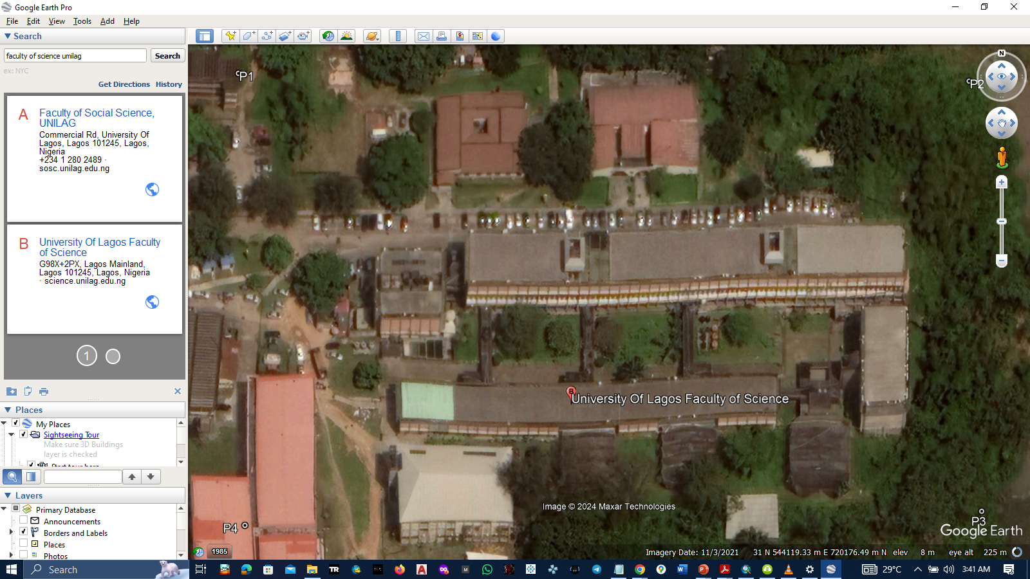

1. GEOREFERENCING

* Launched ArcMap
* Connected to the workfolder via the catalog window.
* Imported image into ArcMap workspace via the catalog window
* Set Dataframe coordinate system to WGS 1984 UTM ZONE 31
* Enabled the georeferencing toolbar from customize – toolbars – georeferencing
* Clicked on add control points
* Using the x,y (Eastings and Northings) coordinates stored in the textfile , the image was georeferenced. The control points were made sure to be added in a clockwise manner

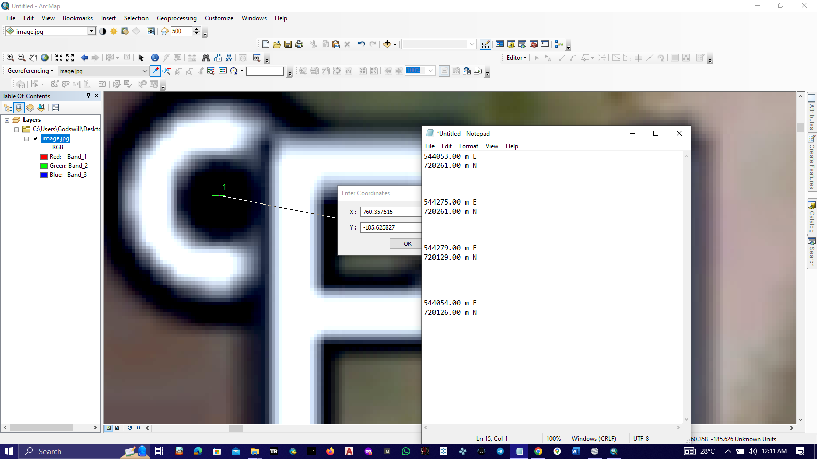

* Checked the view link table for the RMS error which was 0.944 and then fit the image using the projective transformation setting the error to 0.

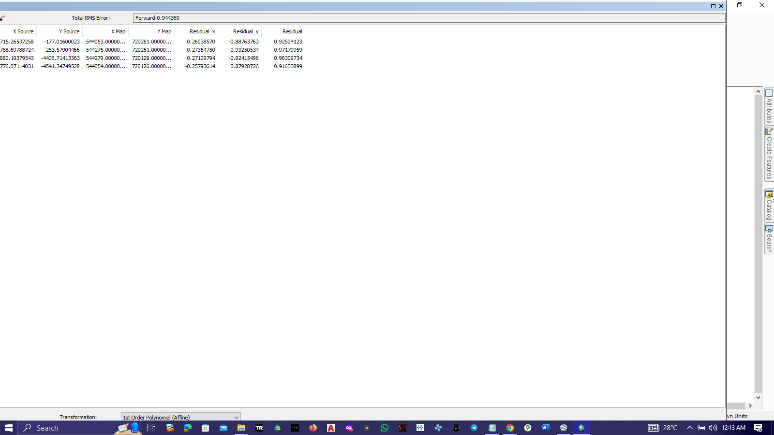

* Updated georefencing

1. SHAPEFILES CREATION

* The shapefiles were created via the catalog window
* Right clicking in the workfolder, go to new – shapefiles
* Set name, feature type, and coordinate system (WGS 1984 UTM ZONE 31)
* 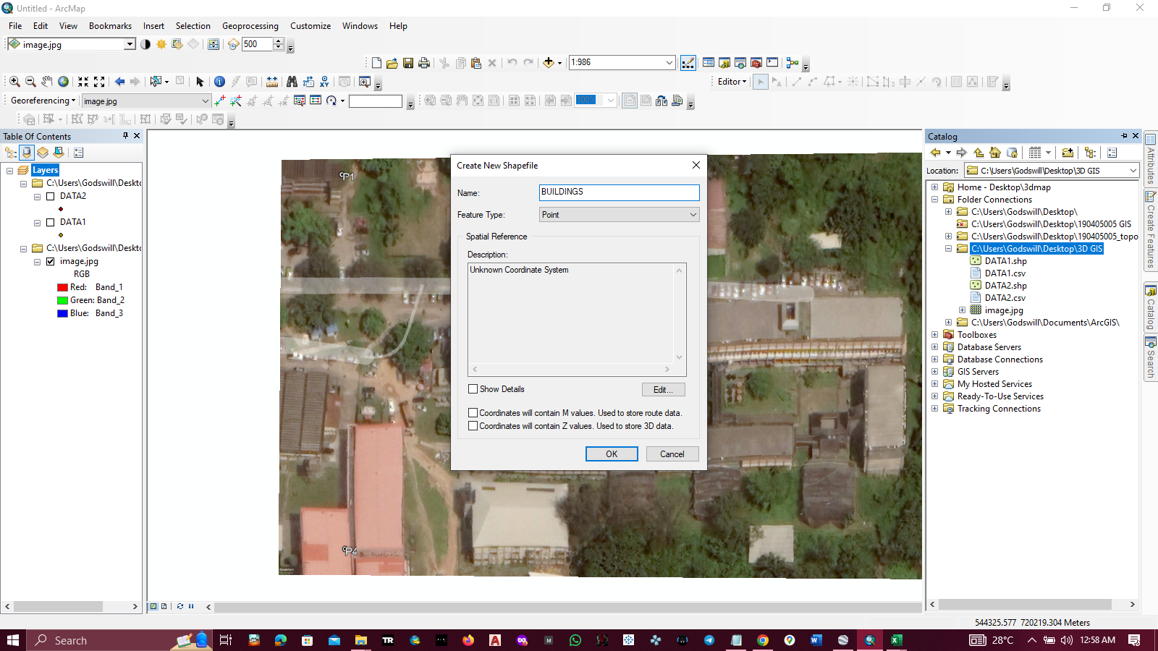The following shapefiles were created: Buildings (Polygon), Boundary (Polygon), Trees(Point), Walkways (Poygon)

1. DIGITIZING

* Launching the editior toolbar via customize – toolbars – editor and enabling it by clicking start editing.
* 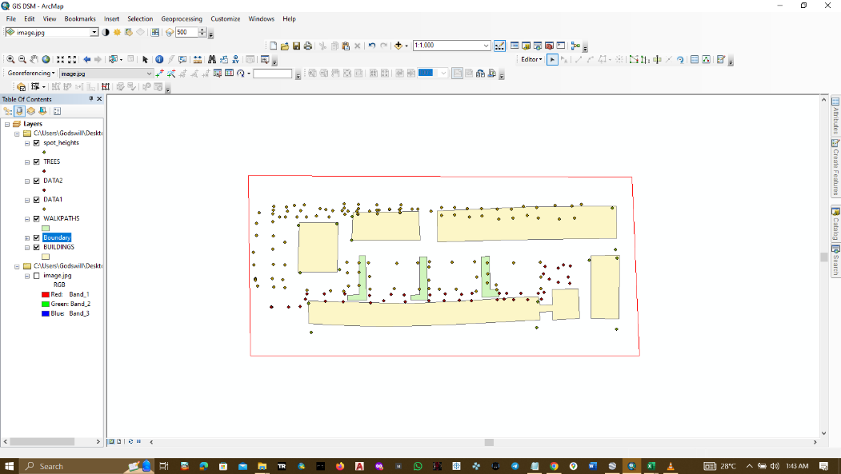Click on the create features icon, click on the feature on interest, choose construction tool and start digitizing.
* Saved edits regularly by clicking Save Edits.

1. CONFIGURING ATTRIBUTE TABLES

* From the site data, the elevation readings of the buildings, walkpaths , and trees where extracted.
* New attribute field ( Name and height / z) were added to the attribute table of the shapefiles

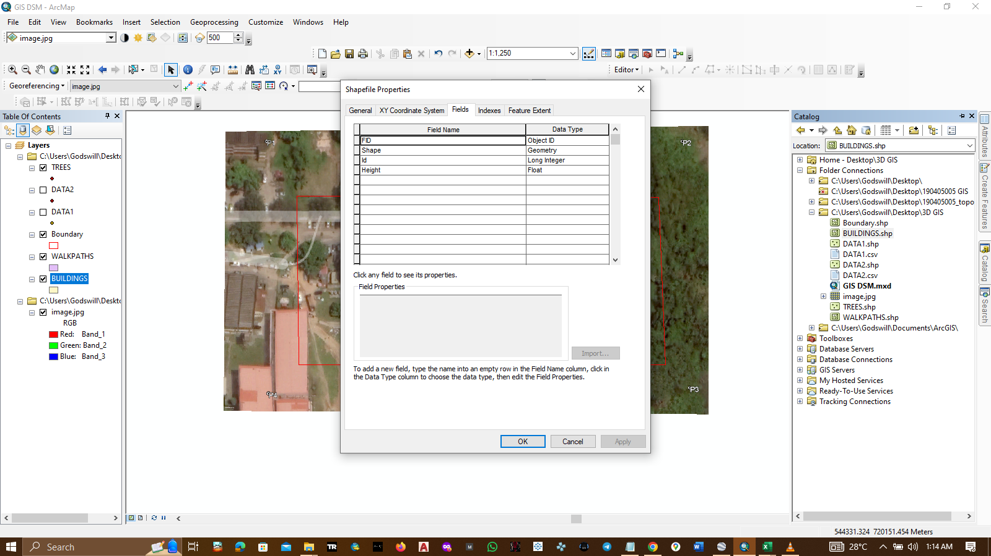

STEPS TO 3D REPRESENTATION OF STUDY AREA

1. IMPORTING SITE DATA INTO ARCMAP

* The cleaned and adjusted site data (COMBINED SPOT HEIGHTS.csv) was imported into the workspace, this created a new layer.
* In order to view the data points, right clicked on the .csv layer and clicked on **Display xy data**
* 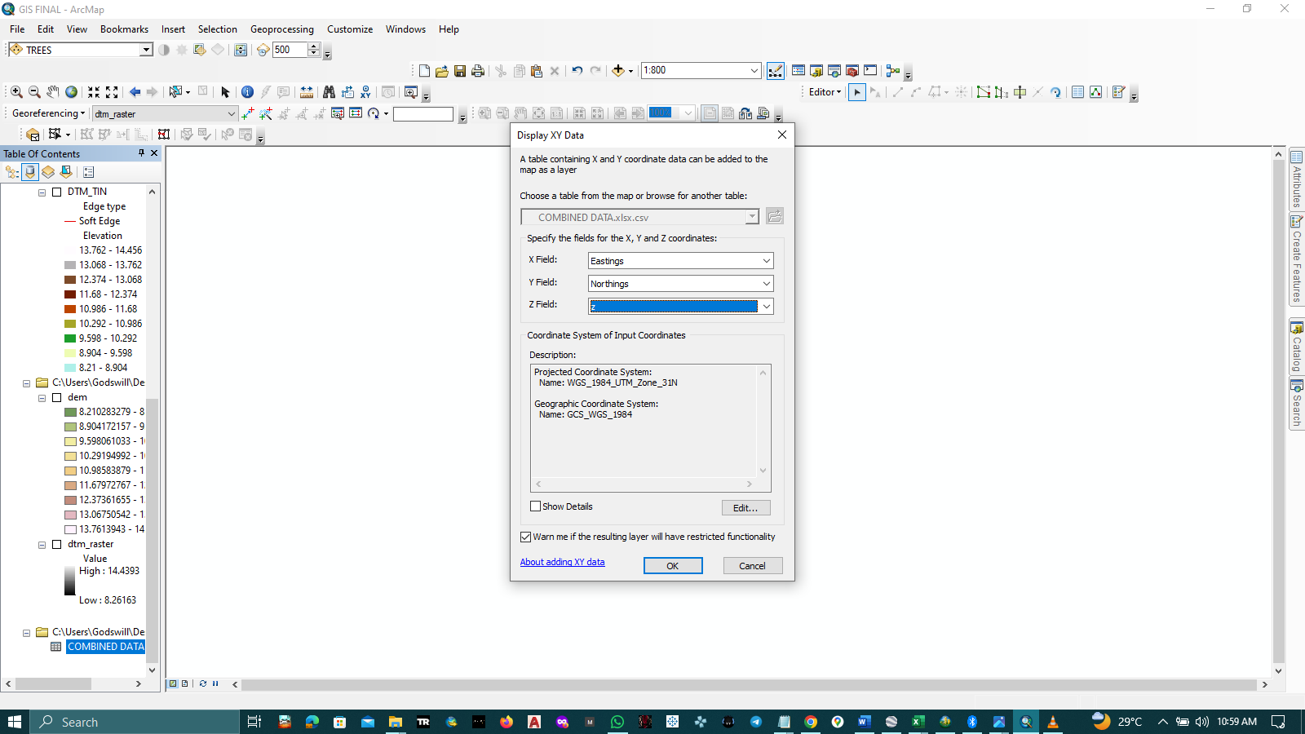Specified the fields for **X,Y,Z ,** coordinates (EASTING, NORTHINGS, Z) and chose coordinate system
* This created a new layer, which was exported to a shapefile by right clicking on it, go to Data – Export Data. The directory chosen was the work folder.

1. **CREATING THE DTM (Triangulated Irregular Network (TIN))**

* From the **ArcToolbox – 3D Analyst Tools - Data Management-TIN-Create TIN** (or just search **create tin** on the search menu)
* A dialog box comes up. Set the directory and name of the TIN file (ours was set to DTM_TIN)
* Choose coordinate system (WGS 1984 UTM ZONE 31)
* Input the spot height (COMBINED DATA.shp) and Boundary.shp data
* Set Height Field and Type. Height Field should be the elevation field
* The spot height field should be set to Mass Points and Boundary, Hard Line. Click Ok

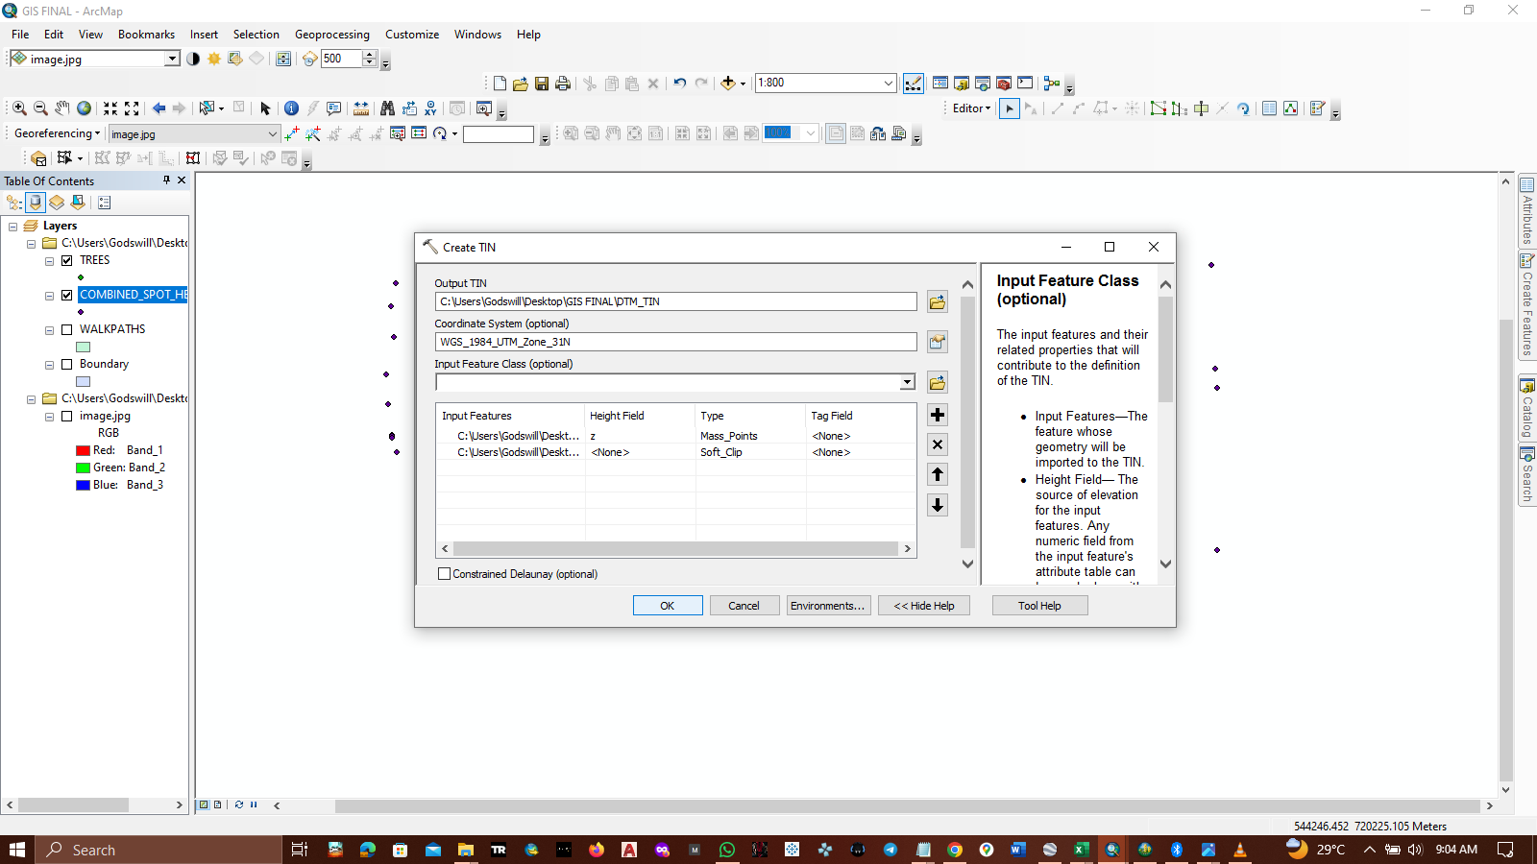

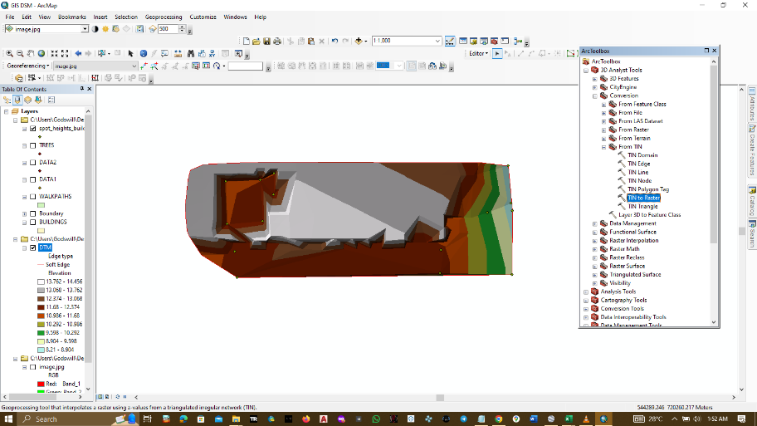

1. **CREATING DTM RASTER**

* On the search menu, search – TIN to Raster
* Input the DTM_TIN file
* Set Output file directory and name
* Set method **to NATURAL_NEIGHBOR** and click OK

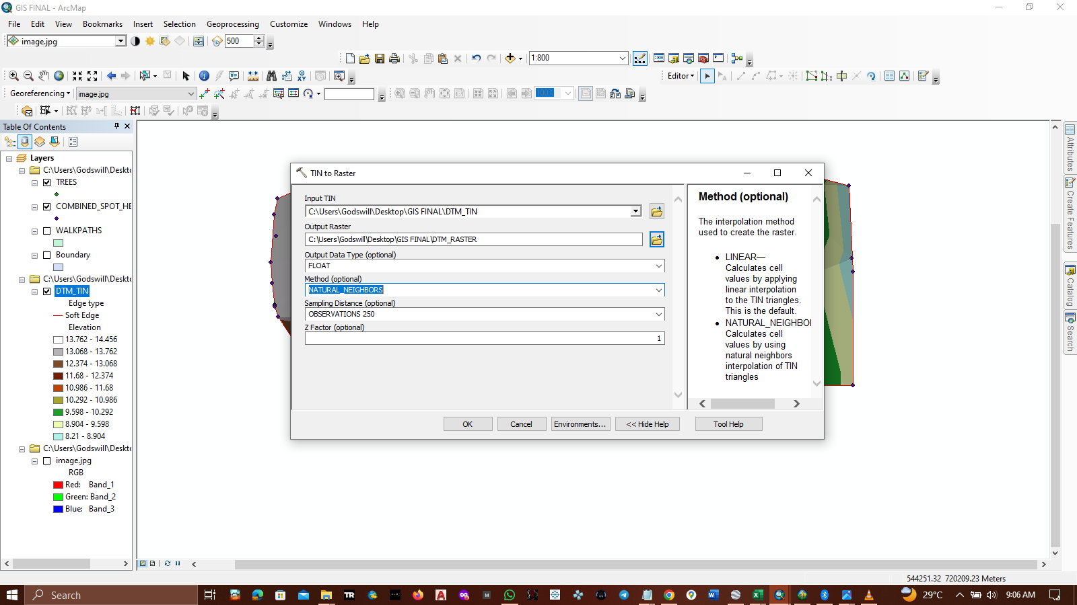

1. **CREATING DEM**

* This was created using the spot height file and the IDW interpolation method
* Searched IDW on the search menu and clicked on the 3D ANALYST tool

This can also be found on ArcToolbos – Spatial Anaylst tools – Interpolation- IDW

* Inputing the spot height data (COMBINED DATA.csv)
* 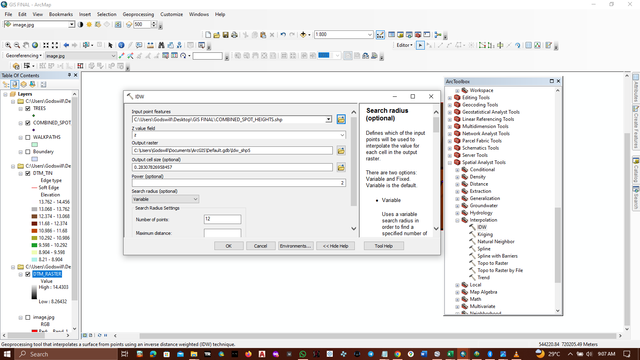Set the Z field and output directory.
* Click OK

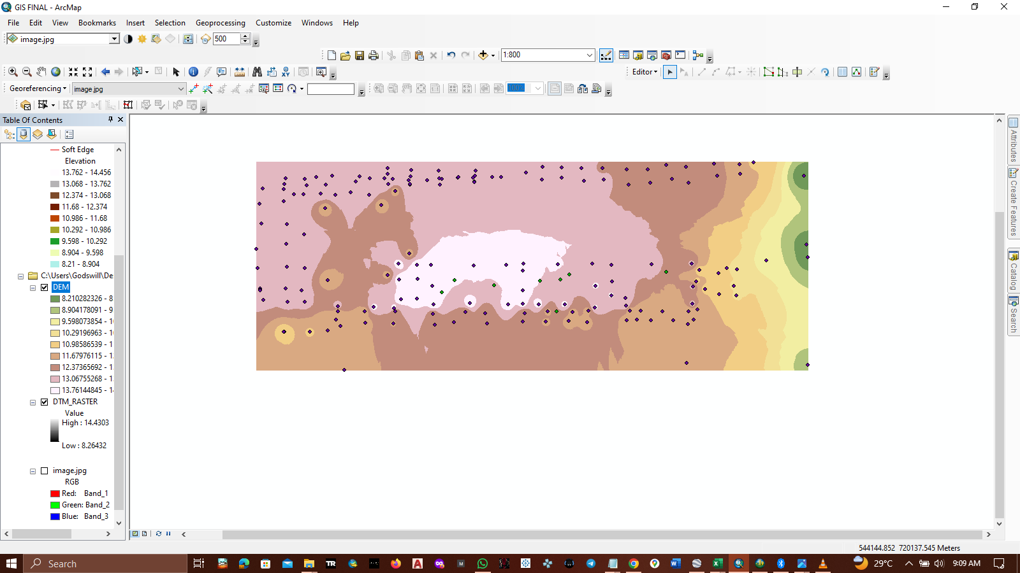

1. **CREATING DSM (Digital Surface Model)**

* Using the **create TIN tool,** input the directory of the output TIN
* Input the coordinate system
* Add feature classes (all Shapefiles i.e. Buildings, spot height (Combined Data), trees, walk paths)
* Set Height Field and Type, click Ok

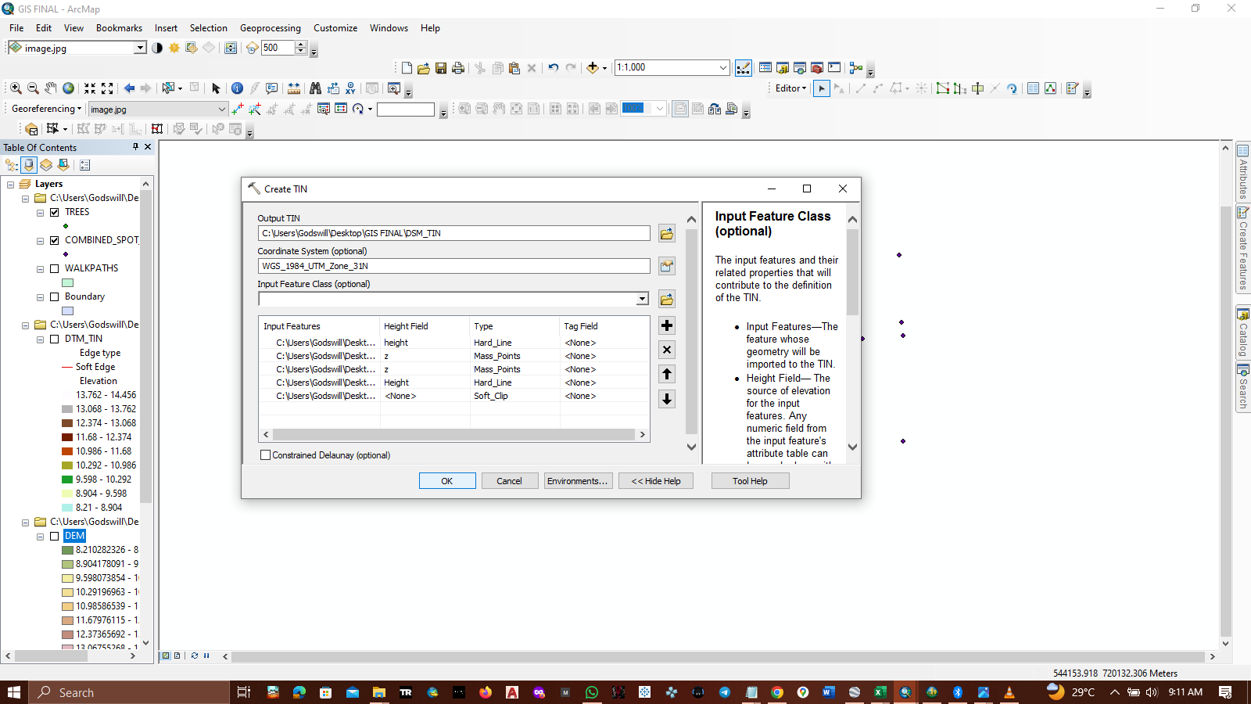

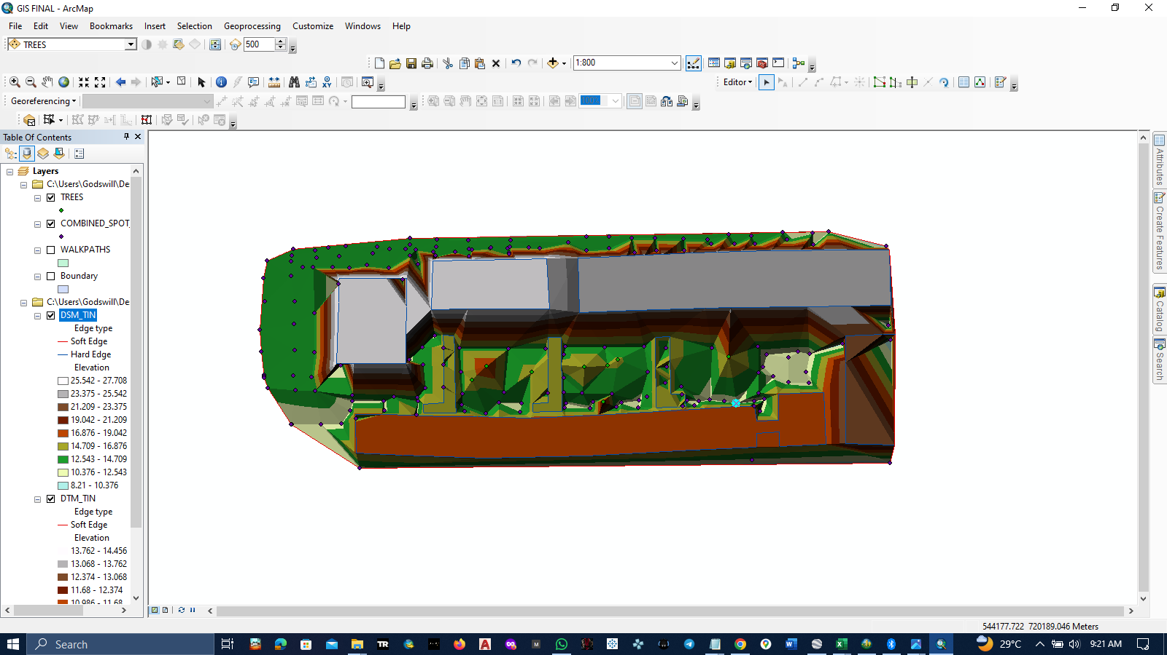

**ALL THE ABOVE WERE DONE ON ARCMAP, THE FOLLOWING WERE DONE ON ARCSCENE**

1. Create a new ArcScence .sxd file
2. 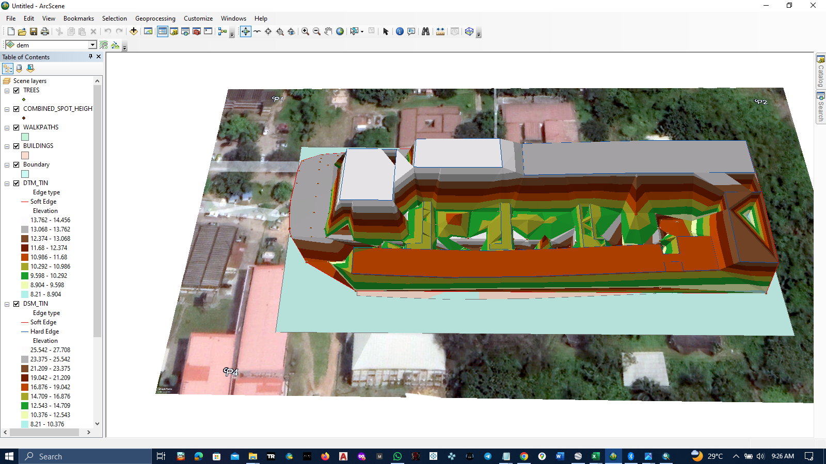Import all required data
3. Convert DSM (DSM_TIN) to raster using the TIN to raster tool
4. Create a **hiilshade** by searching hillshade choosing the input and output raster (Input raster dsm_raster) 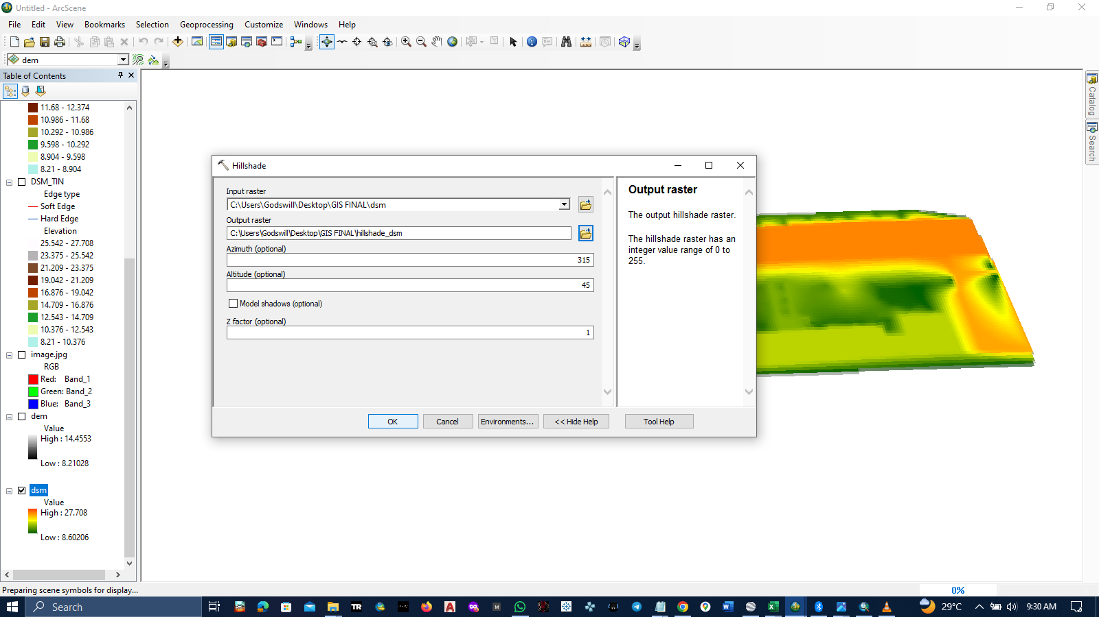
5. 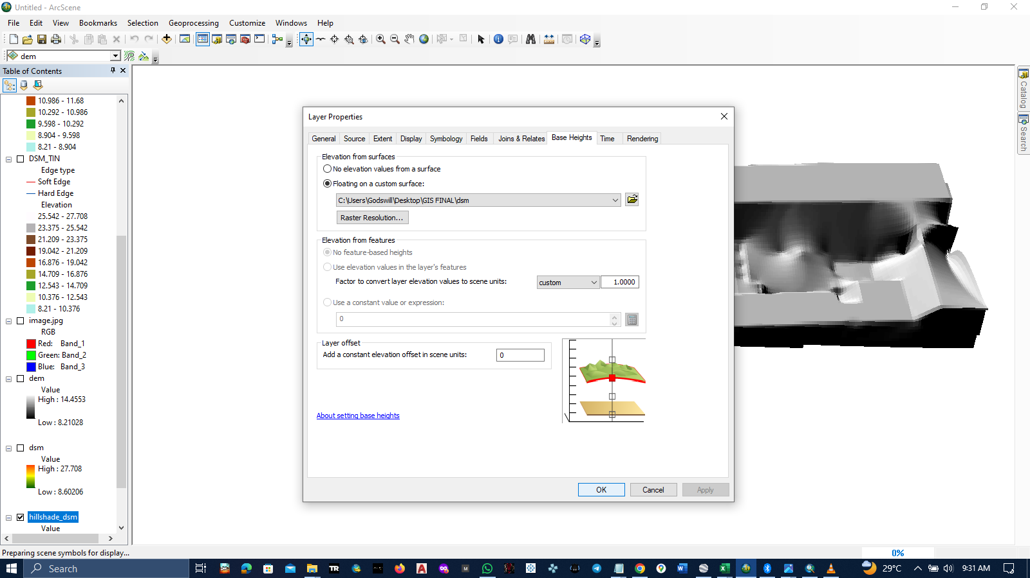Drape the hillshade on the DSM by going to the hillsahde layer properties **– base heights- floating on a custom surface, choosing the DSM** and click OK

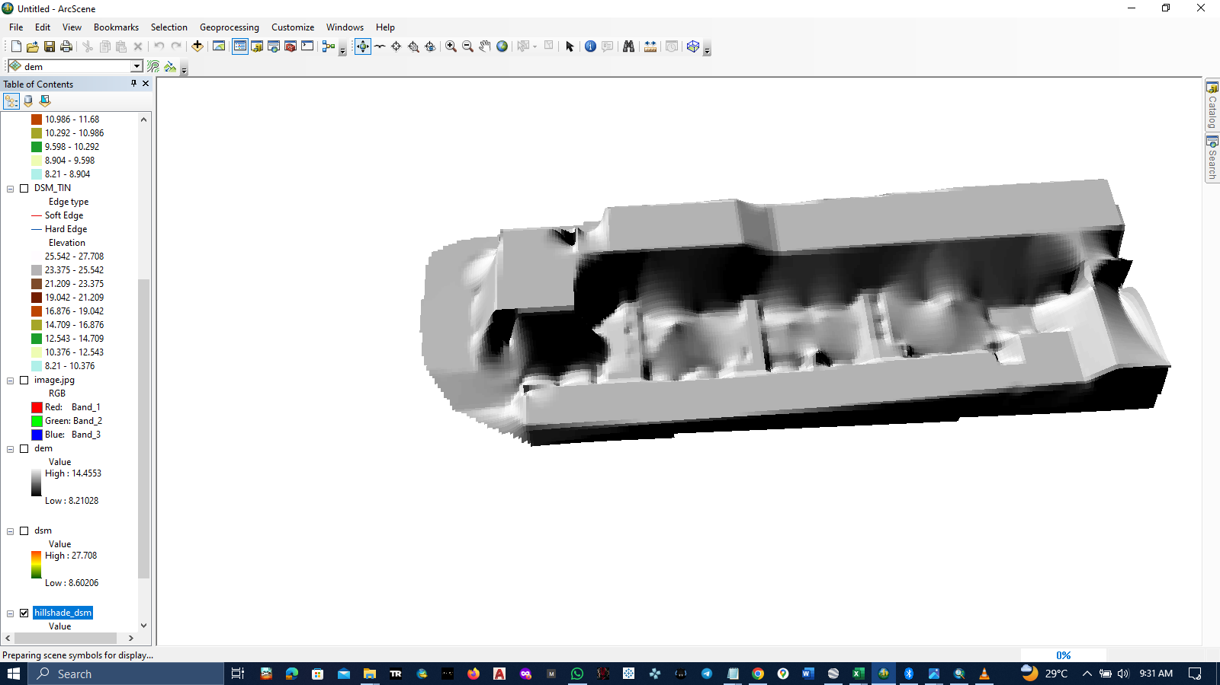

1. Using the same method , draped the image file on the new DSM (hillshade_dsm), turn off the hillshade layer.

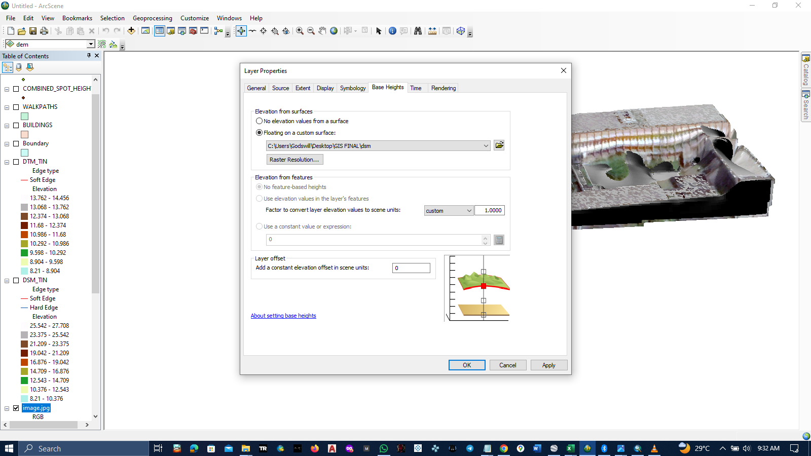

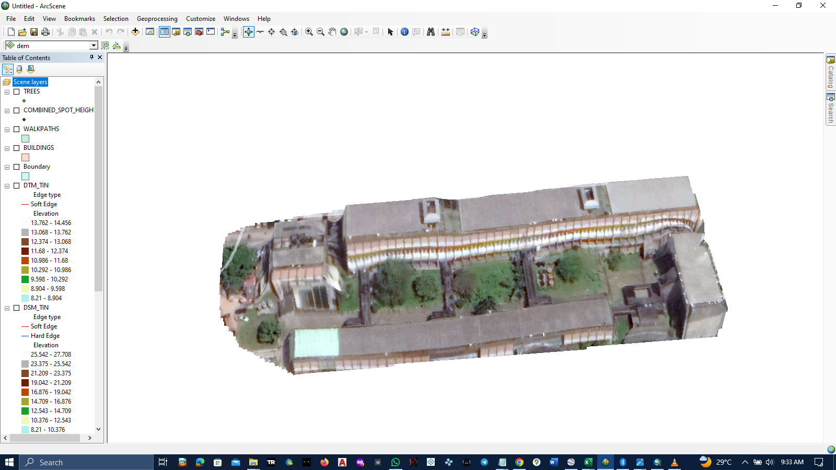

1. Using the same method, created a DTM raster ,hillshade and draped the hillshade on the DTM raster. Called the result hillshade_dtm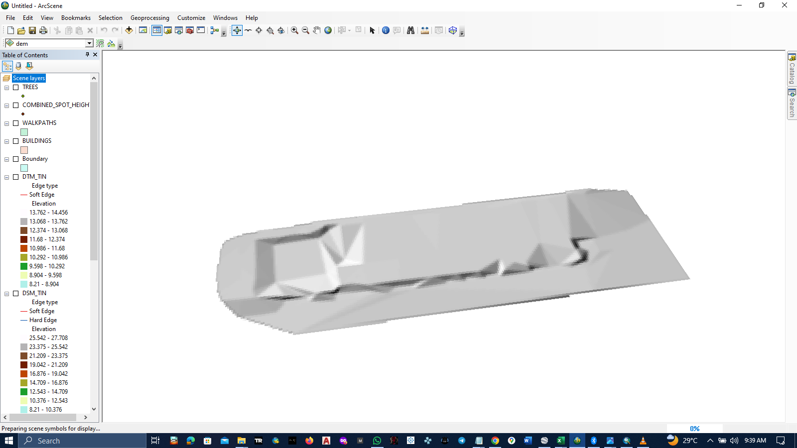
2. Extruded the building and walkway shapefiles and placed them on the hillshade_dtm by going to their layer properties -Extrusion-Tick Extrude features in layer – Choose Extrusion value from the attribute table (height or elevation)

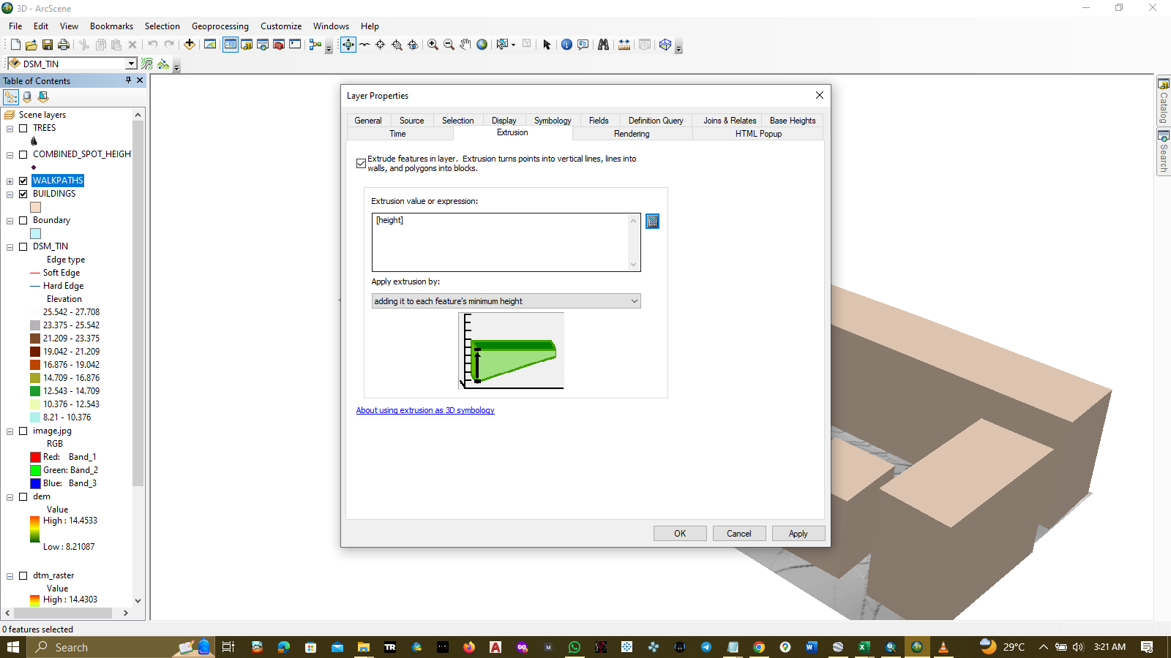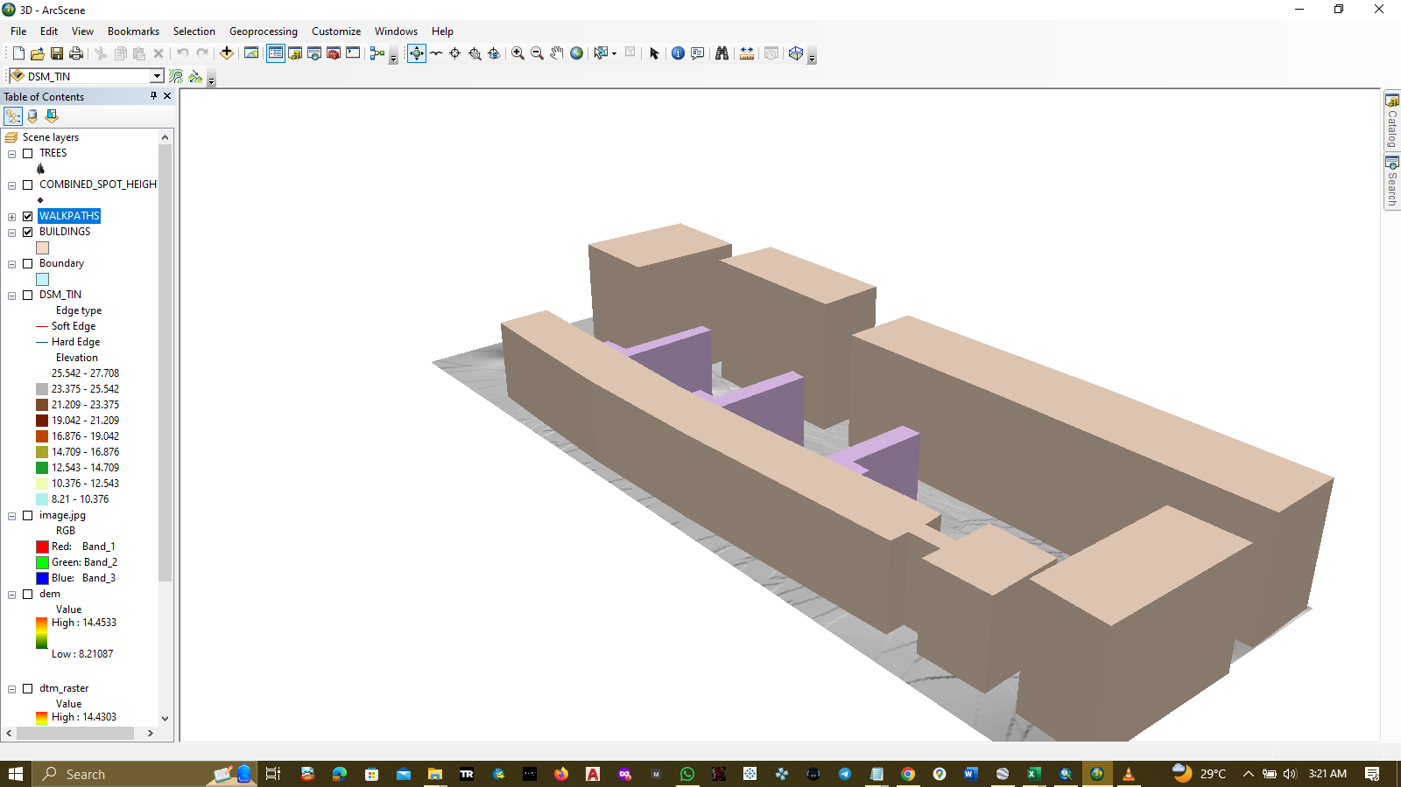

1. Changed symbology by height by going to layer properties – symbology- quantities, and choose value as the elevation data.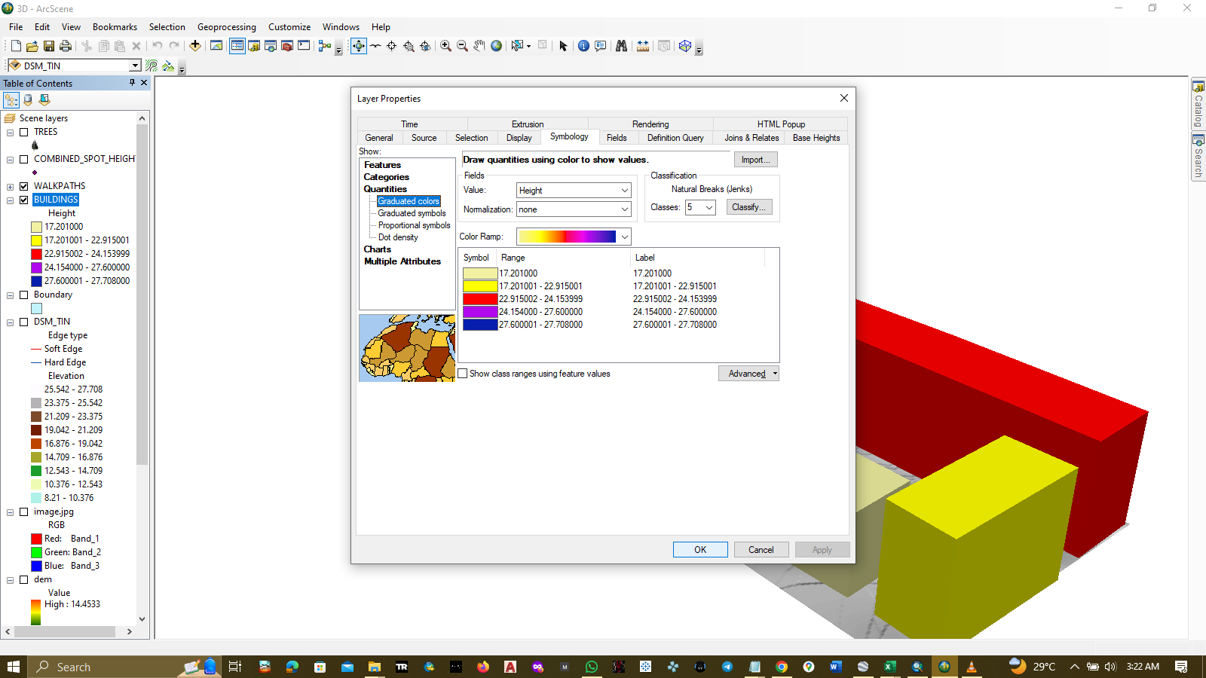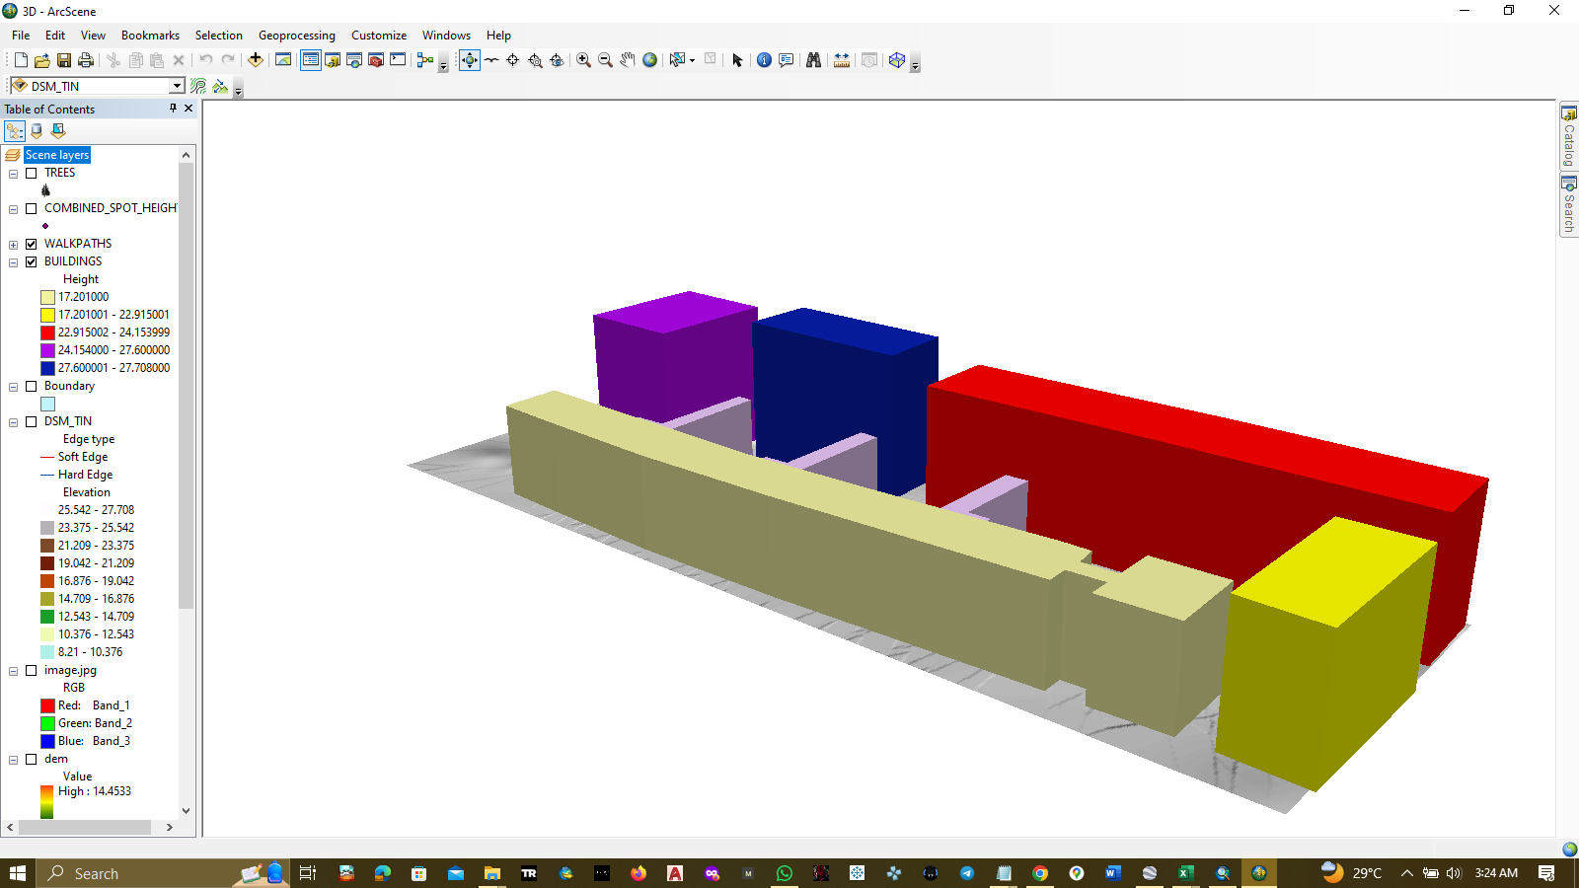

APPENDIX

COMBINED DATA (Cleaned spot height data)

|  |  |  |  |
| --- | --- | --- | --- |
| OBJECTID | Northings | Eastings | z |
| 1 | 720214.125 | 544116.5625 | 13.596 |
| 2 | 720213.9375 | 544119.4375 | 13.608 |
| 3 | 720213.8125 | 544123.8125 | 13.623 |
| 4 | 720213.8125 | 544130.125 | 13.644 |
| 5 | 720214.375 | 544134.875 | 13.617 |
| 6 | 720214.8125 | 544140.1875 | 13.549 |
| 7 | 720215.0625 | 544140.375 | 13.541 |
| 8 | 720214.8125 | 544145.3125 | 13.494 |
| 9 | 720215.0625 | 544151.5625 | 13.421 |
| 10 | 720214.875 | 544154.5625 | 13.392 |
| 11 | 720213.9375 | 544161.25 | 13.34 |
| 12 | 720217.5 | 544117.625 | 13.549 |
| 13 | 720215.5625 | 544117.625 | 13.578 |
| 14 | 720212.3125 | 544117.8125 | 13.626 |
| 15 | 720212.4375 | 544124.375 | 13.651 |
| 16 | 720212.6875 | 544124.375 | 13.646 |
| 17 | 720215.1875 | 544124.5625 | 13.602 |
| 18 | 720217.3125 | 544124.75 | 13.564 |
| 19 | 720212.5 | 544134.1875 | 13.665 |
| 20 | 720214.5625 | 544134.0625 | 13.621 |
| 21 | 720217.0625 | 544133.875 | 13.569 |
| 22 | 720213.1875 | 544145.6875 | 13.525 |
| 23 | 720213.5 | 544145.6875 | 13.519 |
| 24 | 720215.3125 | 544145.9375 | 13.476 |
| 25 | 720217.125 | 544146.125 | 13.435 |
| 26 | 720188.4375 | 544160.3125 | 13.905 |
| 27 | 720188 | 544189.5625 | 13.597 |
| 28 | 720188.0625 | 544202.8125 | 13.451 |
| 29 | 720188.3125 | 544216.25 | 13.301 |
| 30 | 720180.75 | 544216.5625 | 13.462 |
| 31 | 720174.9375 | 544216.4375 | 13.59 |
| 32 | 720174.375 | 544194.3125 | 13.842 |
| 33 | 720176.875 | 544194.125 | 13.79 |
| 34 | 720177.8125 | 544189.4375 | 13.819 |
| 35 | 720182.5 | 544189.75 | 13.714 |
| 36 | 720188.125 | 544171.75 | 13.788 |
| 37 | 720188.4375 | 544183.25 | 13.656 |
| 38 | 720180.9375 | 544184.25 | 13.809 |
| 39 | 720173.8125 | 544184.0625 | 13.964 |
| 40 | 720188 | 544129.6875 | 14.168 |
| 41 | 720187.8125 | 544143.875 | 14.096 |
| 42 | 720187.875 | 544154.5625 | 13.978 |
| 43 | 720174.875 | 544155.25 | 14.253 |
| 44 | 720175.125 | 544142.5625 | 14.386 |
| 45 | 720174.75 | 544130.5625 | 14.456 |
| 46 | 720181 | 544130.125 | 14.318 |
| 47 | 720174.75 | 544174 | 14.054 |
| 48 | 720188.25 | 544118.875 | 13.997 |
| 49 | 720188 | 544124.9375 | 14.094 |
| 50 | 720176.625 | 544125 | 14.301 |
| 51 | 720176.4375 | 544119.75 | 14.194 |
| 52 | 720183.0625 | 544119.0625 | 14.078 |
| 53 | 720183.1875 | 544125.0625 | 14.182 |
| 54 | 720214.125 | 544111.8125 | 13.58 |
| 55 | 720214.1875 | 544095.5 | 13.528 |
| 56 | 720213.9375 | 544089 | 13.508 |
| 57 | 720214.4375 | 544081.6875 | 13.485 |
| 58 | 720213 | 544074.5625 | 13.456 |
| 59 | 720207.9375 | 544073.4375 | 13.42 |
| 60 | 720201.625 | 544073.25 | 13.38 |
| 61 | 720193.3125 | 544071.6875 | 13.307 |
| 62 | 720186.875 | 544072.0625 | 13.268 |
| 63 | 720180.0625 | 544072.9375 | 13.238 |
| 64 | 720179.75 | 544072.9375 | 13.236 |
| 65 | 720179.375 | 544072.9375 | 13.234 |
| 66 | 720176.25 | 544074 | 13.236 |
| 67 | 720175.75 | 544082 | 13.402 |
| 68 | 720212.6875 | 544081.5 | 13.481 |
| 69 | 720208.625 | 544081.5 | 13.471 |
| 70 | 720201.5625 | 544081.75 | 13.456 |
| 71 | 720194.9375 | 544081.625 | 13.44 |
| 72 | 720187.3125 | 544081.75 | 13.424 |
| 73 | 720180 | 544081.3125 | 13.399 |
| 74 | 720175.5625 | 544087.6875 | 13.524 |
| 75 | 720215.75 | 544166.5625 | 13.243 |
| 76 | 720211.6875 | 544166.4375 | 13.332 |
| 77 | 720215.6875 | 544173 | 13.175 |
| 78 | 720212.1875 | 544173 | 13.251 |
| 79 | 720215.3125 | 544179.5625 | 13.111 |
| 80 | 720211.125 | 544180.375 | 13.193 |
| 81 | 720215.3125 | 544186.5 | 13.037 |
| 82 | 720211.5625 | 544186.875 | 13.115 |
| 83 | 720215 | 544194.625 | 12.956 |
| 84 | 720209.875 | 544195.25 | 13.061 |
| 85 | 720214.9375 | 544201.5625 | 12.882 |
| 86 | 720210.4375 | 544202.5 | 12.969 |
| 87 | 720216.375 | 544207.8125 | 12.783 |
| 88 | 720211.75 | 544209.5625 | 12.864 |
| 89 | 720215.875 | 544214.375 | 12.723 |
| 90 | 720210.4375 | 544215.1875 | 12.832 |
| 91 | 720216.9375 | 544223.5 | 12.601 |
| 92 | 720209.875 | 544225.6875 | 12.66 |
| 93 | 720216.6875 | 544232.125 | 11.954 |
| 94 | 720210.4375 | 544233.375 | 11.978 |
| 95 | 720217.25 | 544236.75 | 11.535 |
| 96 | 720174.125 | 544098.625 | 13.766 |
| 97 | 720173.875 | 544110.625 | 14.032 |
| 98 | 720173.625 | 544117.3125 | 14.185 |
| 99 | 720174.875 | 544165.3125 | 14.145 |
| 100 | 720175 | 544160 | 14.199 |
| 101 | 720179.375 | 544160 | 14.104 |
| 102 | 720186 | 544160 | 13.96 |
| 103 | 720210.875 | 544109.9375 | 13.61 |
| 104 | 720214.8125 | 544108.25 | 13.562 |
| 105 | 720215.1875 | 544105.3125 | 13.55 |
| 106 | 720211.625 | 544103.625 | 13.574 |
| 107 | 720217.125 | 544097.5 | 13.519 |
| 108 | 720210.875 | 544098.5625 | 13.556 |
| 109 | 720216.75 | 544092.3125 | 13.511 |
| 110 | 720211.125 | 544093.6875 | 13.533 |
| 111 | 720216 | 544088.5 | 13.504 |
| 112 | 720211.0625 | 544087.9375 | 13.506 |
| 113 | 720216.375 | 544082.1875 | 13.491 |
| 114 | 720211 | 544084.875 | 13.492 |
| 115 | 720198.1875 | 544087.5625 | 13.51 |
| 116 | 720186.8125 | 544087.625 | 13.517 |
| 117 | 720179.5 | 544086.6875 | 13.502 |
| 118 | 720186.1875 | 544218.6875 | 11.32 |
| 119 | 720186.9375 | 544227.8125 | 10.977 |
| 120 | 720186.375 | 544231.1875 | 10.693 |
| 121 | 720180.9375 | 544230.125 | 10.907 |
| 122 | 720177.75 | 544231.0625 | 10.893 |
| 123 | 720178.125 | 544225.1875 | 11.396 |
| 124 | 720185.25 | 544225.125 | 11.244 |
| 125 | 720179.8125 | 544220.625 | 11.438 |
| 126 | 720182.4375 | 544217.75 | 11.412 |
| 127 | 720173.1875 | 544218.1875 | 11.608 |
| 128 | 720169.625 | 544216.875 | 11.701 |
| 129 | 720172.5625 | 544215.125 | 11.655 |
| 130 | 720169.5 | 544210 | 11.777 |
| 131 | 720172.5625 | 544206.4375 | 11.749 |
| 132 | 720169.5 | 544202.625 | 11.857 |
| 133 | 720172.625 | 544199.1875 | 11.827 |
| 134 | 720169.6875 | 544198 | 11.903 |
| 135 | 720172.75 | 544195.6875 | 11.861 |
| 136 | 720169.4375 | 544194.5625 | 11.947 |
| 137 | 720172.75 | 544181.8125 | 12.012 |
| 138 | 720168.9375 | 544181.4375 | 12.099 |
| 139 | 720172.1875 | 544176.625 | 12.08 |
| 140 | 720169.3125 | 544175.375 | 12.156 |
| 141 | 720172.375 | 544168.3125 | 12.167 |
| 142 | 720169 | 544167.6875 | 12.247 |
| 143 | 720171.9375 | 544160.625 | 12.26 |
| 144 | 720169.0625 | 544160.1875 | 12.326 |
| 145 | 720171.9375 | 544147.5625 | 12.402 |
| 146 | 720168.5 | 544148.1875 | 12.469 |
| 147 | 720172.1875 | 544141.125 | 12.465 |
| 148 | 720168.875 | 544137.25 | 12.579 |
| 149 | 720171.5625 | 544130.3125 | 12.516 |
| 150 | 720168 | 544130.875 | 12.604 |
| 151 | 720172.5 | 544117.6875 | 12.209 |
| 152 | 720168.4375 | 544117.125 | 12.254 |
| 153 | 720172.4375 | 544107.5625 | 11.978 |
| 154 | 720168.625 | 544107.875 | 12.023 |
| 155 | 720172.4375 | 544098.625 | 11.775 |
| 156 | 720169.75 | 544098 | 11.775 |
| 157 | 720166.0625 | 544095.3125 | 11.725 |
| 158 | 720165.6875 | 544089.4375 | 11.574 |
| 159 | 720165.75 | 544080.9375 | 11.354 |
| 160 | 720165.75 | 544080.75 | 11.349 |
| 161 | 720191.6875 | 544122.5 | 11.994 |
| 162 | 720211.1875 | 544121.625 | 11.659 |
| 163 | 720215.625 | 544252.4375 | 8.21 |
| 164 | 720194.625 | 544254.1875 | 8.52 |
| 165 | 720167.5 | 544099.5625 | 11.826 |
| 166 | 720168.3125 | 544215 | 11.749 |
| 167 | 720155.375 | 544214.5 | 12.035 |
| 168 | 720153 | 544100.75 | 11.952 |
| 169 | 720206.6875 | 544094.5 | 11.553 |
| 170 | 720207.5 | 544113.9375 | 11.672 |
| 171 | 720184.5625 | 544115.125 | 11.988 |
| 172 | 720182.9375 | 544095.25 | 11.655 |
| 173 | 720189.3125 | 544240.875 | 9.791 |
| 174 | 720190.375 | 544254.75 | 8.561 |
| 175 | 720154.625 | 544254.625 | 9.349 |